Implementation Plan:

select * from v$encryption_wallet;

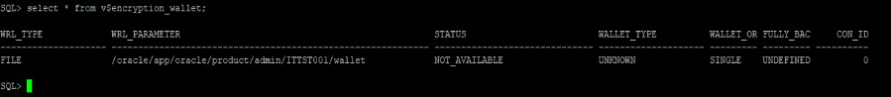

select t.name,e.ENCRYPTIONALG,e.ENCRYPTEDTS from V$ENCRYPTED_TABLESPACES e, v$tablespace t where t.ts#=e.ts#(+);

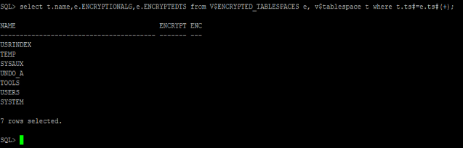

1. Create below directory structure to store wallet password

mkdir -p /oracle/app/oracle/product/admin/ITTST001/wallet/



2. Comment the below parameters in sqlnet.ora file

# sqlnet.ora

#

#NAMES.DEFAULT_DOMAIN = world

#NAMES.DIRECTORY_PATH = (TNSNAMES,EZCONNECT)

3. Update the Wallet directory path in sqlnet.ora file

ENCRYPTION_WALLET_LOCATION=

(SOURCE=

(METHOD=FILE)

(METHOD_DATA=

(DIRECTORY=/oracle/app/oracle/product/admin/ITTST001/wallet/)))

SQLNET.ALLOWED_LOGON_VERSION_SERVER=8

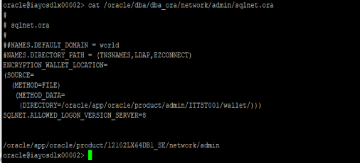

-- 4. Create a Restore point

create restore point before_tde guarantee flashback database;

5.Create Keystore

administer key management create keystore '/oracle/app/oracle/product/admin/ITTST001/wallet/' identified by Haleon#123;

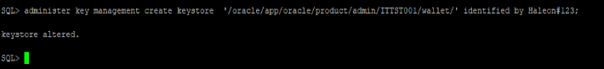

6.Open the Keystore

administer key management set keystore open identified by Haleon#123;

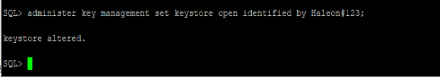

7. Validate the encryption status

select * from v$encryption_wallet;

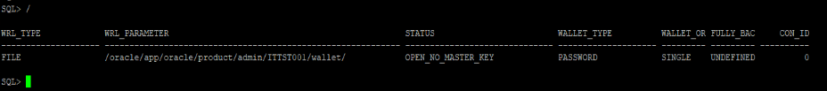

7. Create Master Key

administer key management set key identified by Haleon#123 with backup;

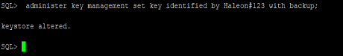

8. Create an auto-login Keystore

administer key management create auto_login keystore from keystore '/oracle/app/oracle/product/admin/ITTST001/wallet/' identified by Haleon#123;



9. Close the password Keystore and open the auto-login Keystore

administer key management set keystore close identified by Haleon#123;

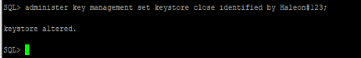

10. Validate the encryption status

select * from v$encryption_wallet;

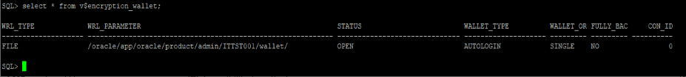

11. Encrypt the tablespace

Alter tablespace USERS encryption online encrypt;

Alter tablespace TOOLS encryption online encrypt;

Alter tablespace USRINDEX encryption online encrypt;

12. Create below directory structure to store the wallet backup files

mkdir -p /oracle/app/oracle/product/admin/ITTST001/wallet

13. Create shell script to take backup of cwallet.sso and ewallet.p12 files and schedule cronjob for every 12hrs backup.

00 */12 * * * /oracle/dba/wallet_ITTST001_env.sh OITTST001 < /dev/null